DOKUZ EYLUL UNIVERSITY
ENGINEERING FACULTY
DEPARTMENT OF COMPUTER ENGINEERING

CME1251 PROJECT BASED LEARNING – III
FINAL REPORT
PROJECT – III

SHAPER

by
Kerem KALINTAŞ
Ali Özgür İNEP
Nisa AYDIN

Lecturers
Dr. Meltem YILDIRIM
Dr. Özlem ÖZTÜRK

04.01.2023

CHAPTER ONE
PROGRESS DESCRIPTION
Roughly, the project is all around the central idea that the player earns points by living as long as possible. Avoiding enemies, earning points and collecting mines should be the main objectives of the player. We immediately started to think about the project when it was given by our teachers and we completed the project on 29.12.2022. Although we faced some obstacles when we tried to solve some bugs, we overcame all the problems thanks to research.

CHAPTER TWO
TASK SUMMARY

Completed Tasks
All required requirements have been completed.

Incomplete Tasks: Reasons and Explanations
There is no incomplete task.

Additional Improvements to the Project

Firstly, the functions made the readability of the project easier. In addition to functions, the difficulty has been set as the player can choose the mode(easy, normal, hard). Changing player, enemies, mines and numbers colours is another additional improvement. Furthermore, when an enemy steps on a mine, we added a simple explosion animation.

CHAPTER THREE
EXPLANATION of algorıthms

Screenshots
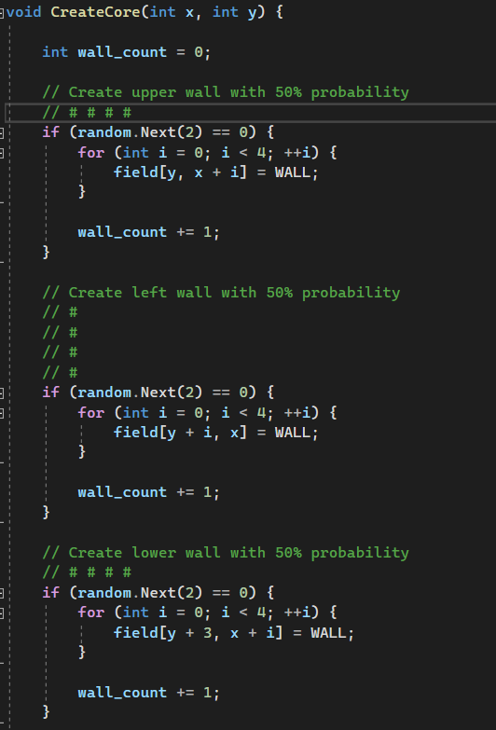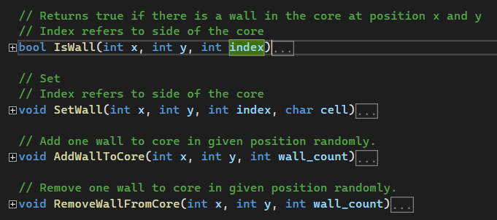

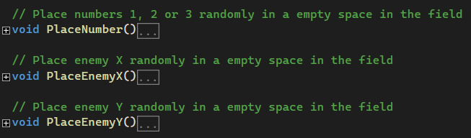
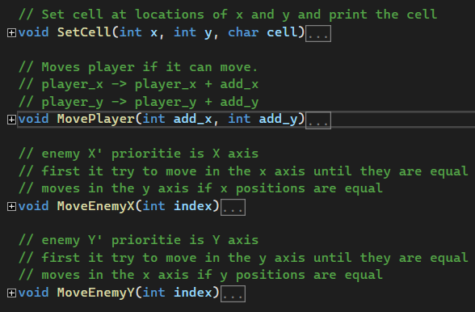

Functions
Although the functions stated briefly with comment lines, these need to be explained what these work.
CreateCore: Our parameters is x and y which they needed for placement on the console. It randomly generated inner walls like a maze with a 50% possibility for each wall. These walls can be at least 1 at most 3.
IsWall: To determine whether there is a wall or not.
SetWall: To set walls to be removed or added later for every time unit. The wall which will be removed or added determines randomly.
AdWallToCore: To add wall which was determined in “SetWall” function.
RemoveWallFromCore: To remove wall which was determined in “SetWall” function.
PlaceNumber: To place numbers which mean point on the console with their own possibilities. The number of points should be 20 with their own probabilities.
PlaceEnemyX: To place X enemies on the screen. At first 2 X have to be in the game.
PlaceEnemyY: To place Y enemies on the screen. At first 2 Y have to be in the game.
SetCell: To set cells at locations of x and y and print the cell.
MovePlayer: To move the player if there is no wall. The old coordinates of the player are turned into space by using the “SetCell” function and the new coordinates of the player are no more space, at this point “P” should be written.
MoveEnemyX: Firstly, X enemies try to catch the same x coordinates as the player because of the x-axis priority. Then, they can move on the y-axis if they have the same x coordinates as the player.
MoveEnemyY: At first, Y enemies try to catch the same y coordinates as the player because of the y-axis priority. Afterwards, they can move on the x-axis if they have the same y-coordinates as the player.

Algorithms and Solution Strategies
Simply, functions made the readability of the project easier. In addition, loops which are needed for the continuity of the game take a significant role.
By using while loops we made the program not close automatically and we asked the user whether he/she wanted to go on or not.

CHAPTER FOUR
PROBLEMS ENCOUNTERED
Mostly, display errors occured becuse of the “SetCursorPosition”. By making small calculations we handled this problem.

CHAPTER FIVE
conclusıon
In conclusion, we made a game which is similar to PacMan. Basically, gaining points and escaping from enemies is our main goal. We learned to use arrays how can we design them by using for loops, and to use functions to make the readability of the code easier. However, the main thing is to work as a team on some transactions. We improved the sociality among us in a positive way while we made this project.

AppendIx B
Code of the Project
First of all, we defined the sections that will be used more than once as functions and used the function related to them. We used the “Thread.Sleep” to adjust the speed of the game. In general, we used if-else, switch-case, array rotation using for loop, while loop to ensure the continuity of the program, and random command structures.

